OPERATING SYSTEM PROJECT 2 REPORT

1-) Introduction

First, we have to reach path variable folder to execute shell command in our shell. Here is some screenshots of our shell.

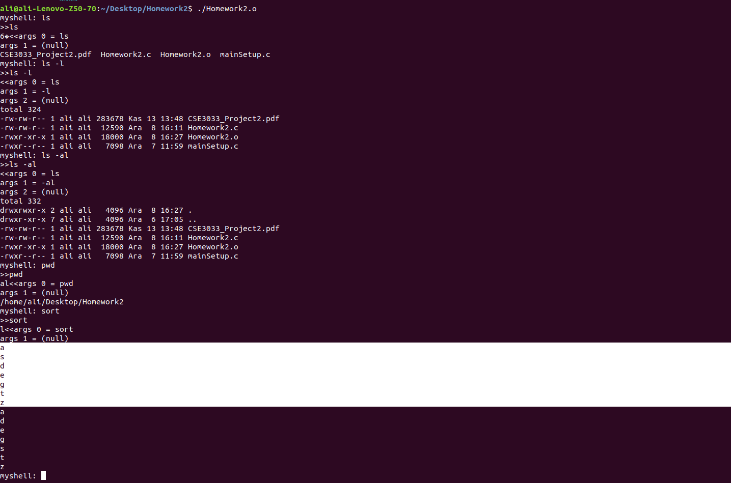

2-) Foreground and Background Processes

When a command is executed in foreground(withouth having &), our shell waits fort he
process(task) to execute to complete its job. Once it’s finished, the user is immediately
allowed to enter another command in our program which is what we’re expected to handle.

When a command is executed in background(with having &), our shell does not wait for the
process(task) to execute to complete and the user is expected to enter another command
immediately.

fg command:

It takes all background processes to foreground.

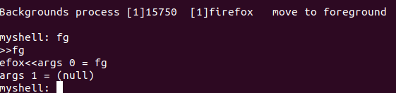

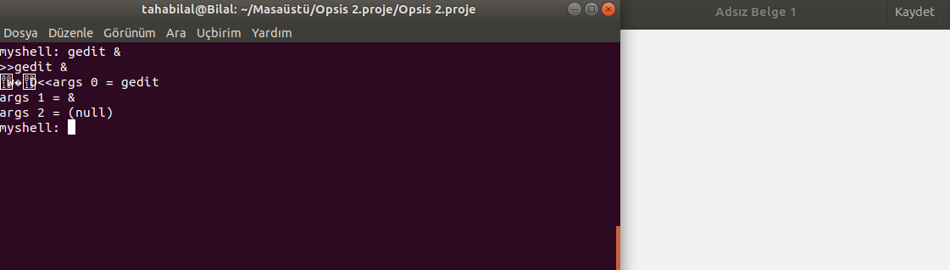

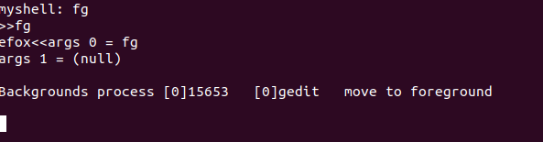

exit command :

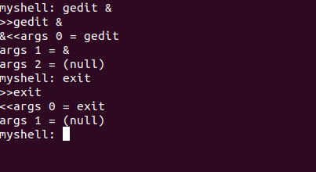

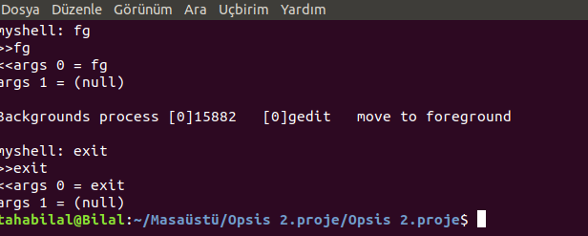

3-) Alias Processes

How To Add Alias ?

In this part command names called by another name. For example, alias “ls -l” list. From now on, if user type list and press enter. Shell going to execute “ls -l” command.

Format of adding alias

myshell: alias “command name” aliasName

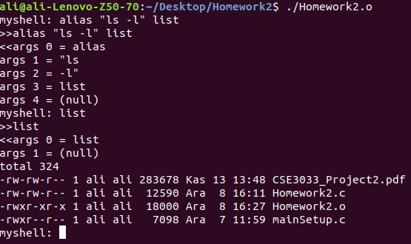

How To Print Aliases ?

If user type alias -l command in shell, it returns the list of alias processes.

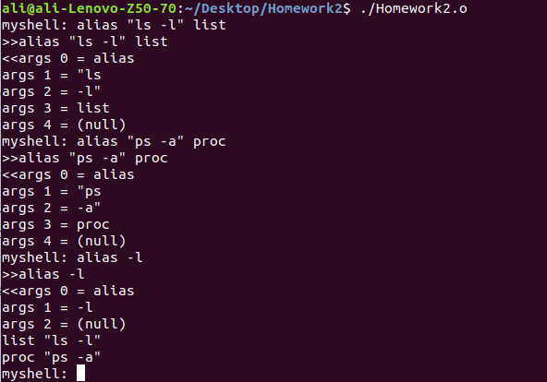

How To Remove Alias Processes ?

If user type unalias list. The alias name of the processes remove from alias list.

Deleting Alias Format

myshell: unalias aliasName

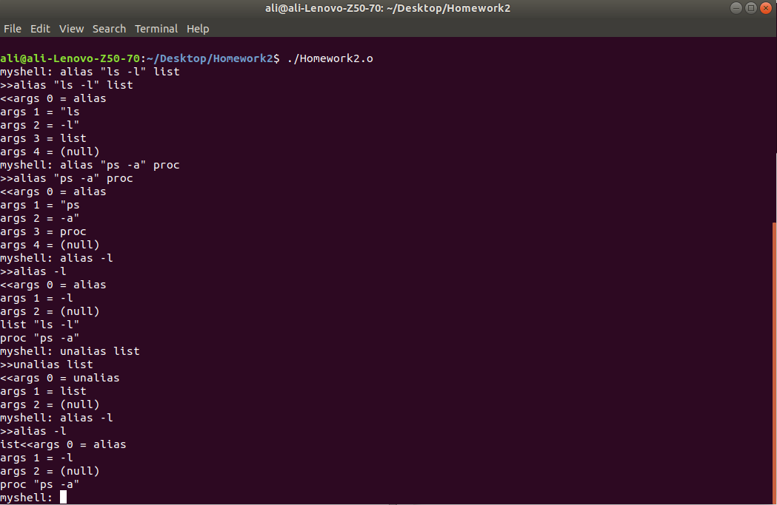

clr in our shell

Clear is the command which slides terminal down. In our shell clr command makes it.

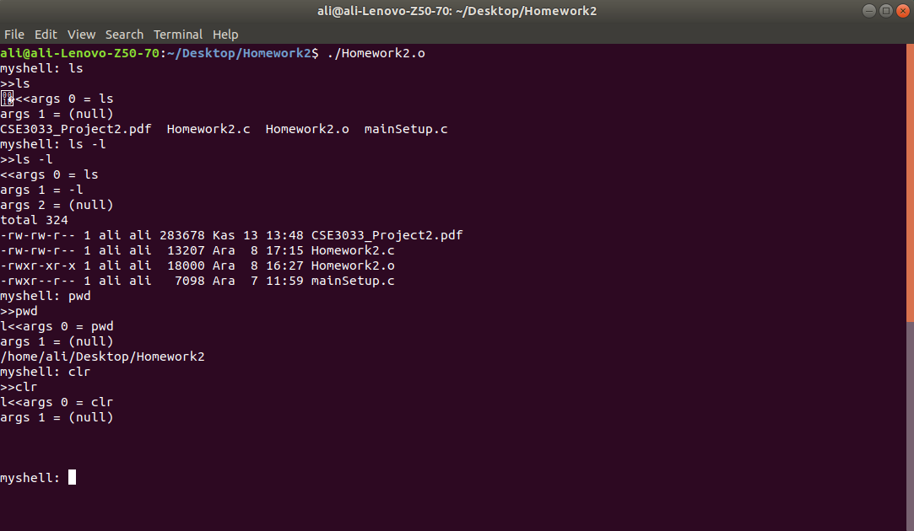

4-) Redirection

We have used dup2 function to make redirection the result of commands and print the result
to the file by using this method in our code.

> It takes the result of the command(i.e ls) and print it out to the file.File name is taken by
the user.

>> It takes the result of the command (i.e ls) and print it out to the file with append.File name
is taken by the user.

2> It takes the result of command which does not exist and give error message to the file.

< This redirection operand used in sort command. If user type sort < opsis.txt. Command take opsis.txt as an input and prints to the screen.

< file.txt > file1.txt: This redirection type makes file.txt as an input an gives output in to the file1.txt. For instance sort < opsis.txt > sortedopsis.txt.

